02nd March 2017

**YOKOHAMA Rubber Launch Special 100th Anniversary Micro-site**

In connection with its 100th Anniversary celebrations running throughout 2017, the Japanese premium tyre manufacturer YOKOHAMA has launched a historical micro-site which highlights the different milestones in the company’s history and products.

The attractive micro-site has been created with two distinct timelines which display the corporate historical timeline from its origins until today and the product timeline as well as some special videos telling the YOKOHAMA story.

Since its foundation in the city of YOKOHAMA, Japan in 1917, The Yokohama Rubber Company has evolved into one of the leading Global tyre manufacturers, with Headquarters in Tokyo and present in 120 countries. Recognised for its pioneering technology and innovation and catering for a wide range of tyres which include the full range of passenger car tyres, Truck and Bus, Motorsport and OTR tyres. Whether fuel saving with environmental credentials or high-performance tyres, YOKOHAMA Rubber continues with its essential philosophy to contribute to society by creating beneficial products.

“To enrich people’s lives and contribute to their greater happiness and well-being by devoting our wholehearted energies and advanced technology to the creation of beneficial products.”

In addition to its tyre business The Yokohama Rubber Company also has other diverse business interests through its know-how and expertise in rubber polymer to produce industrial products for the Marine and Aerospace industry as well as professional Golf products.

The Micro-site can be accessed via the link below;

[**http://www.y-yokohama.com/global/100th/**](http://www.y-yokohama.com/global/100th/)

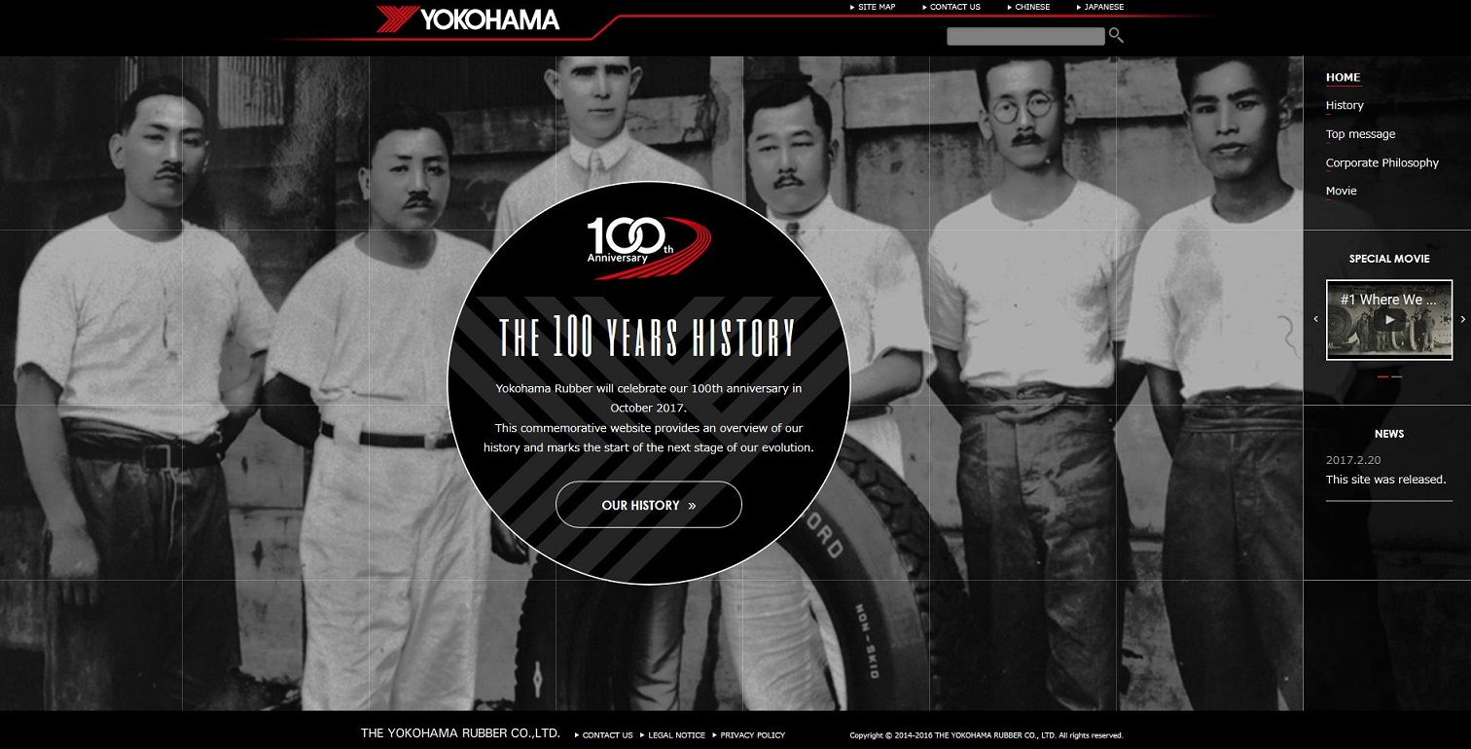

*Yokohama Rubber 100th Anniversary Micro-site pic 1*

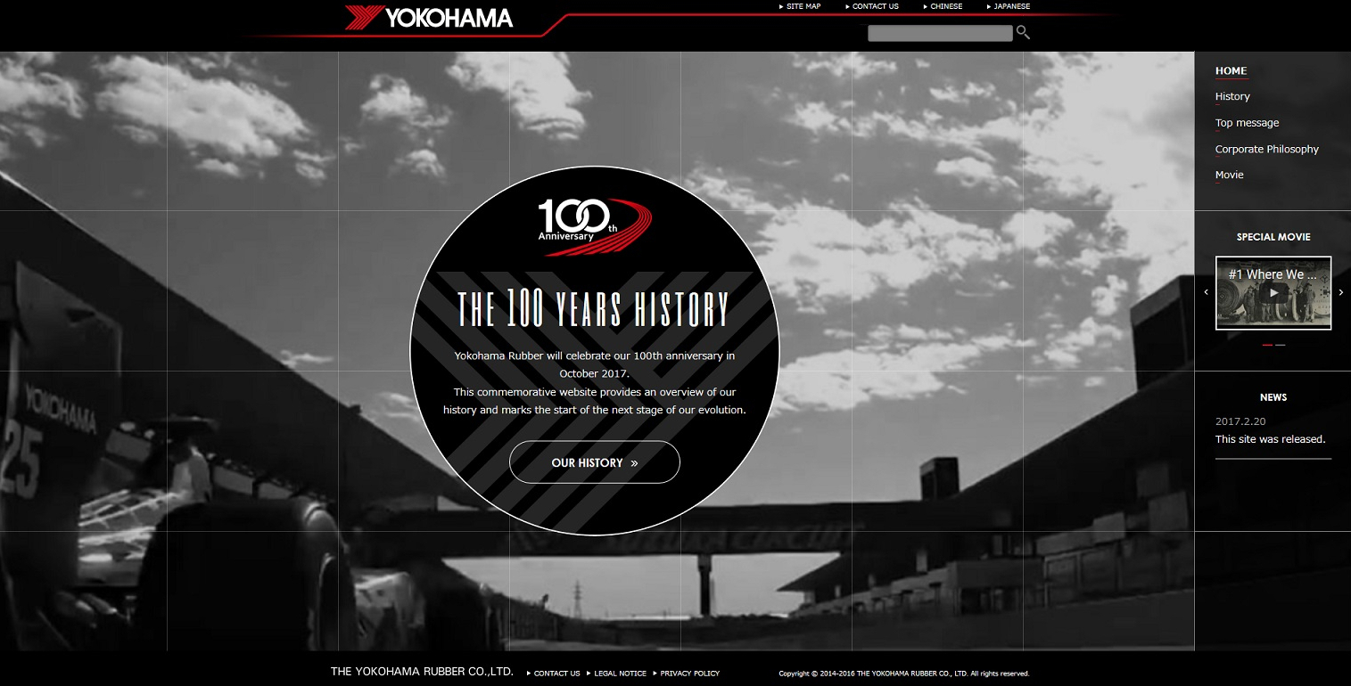

*100th Anniversary Yokohama Rubber Micro-site pic 2*